* L2.7 Routing

1. Use vue router



1. Vue router features

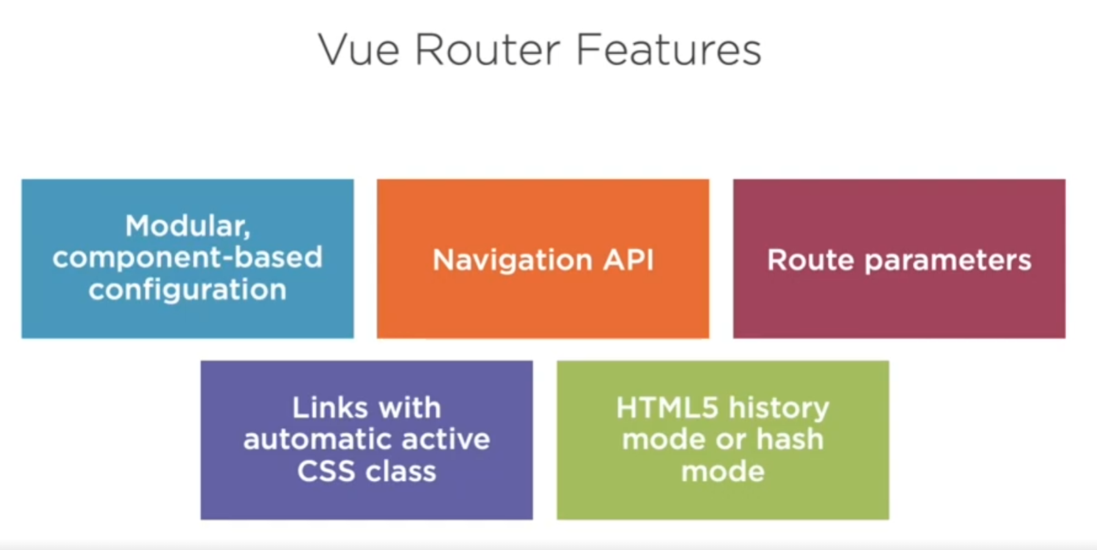

1. Goal

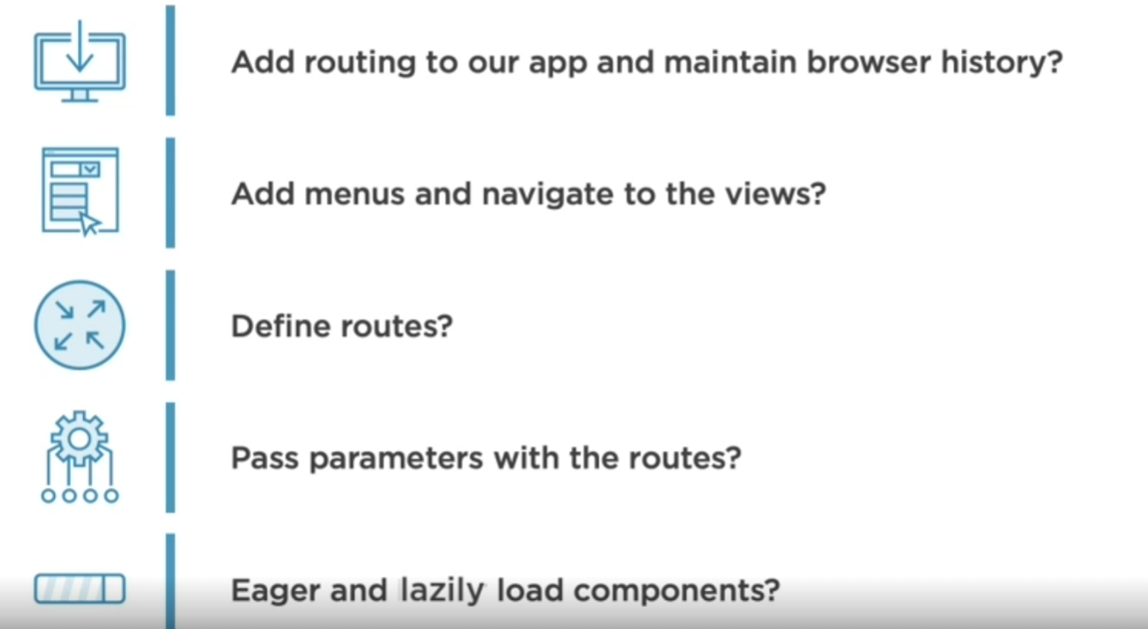



* Get start

1. Install router through vue cli

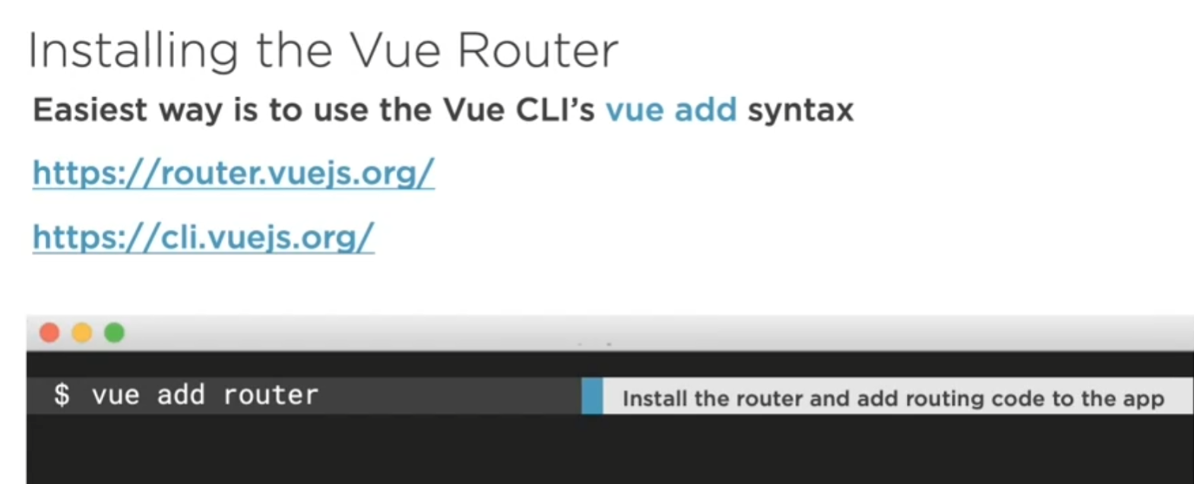

** 單字: pun intended: 帶有雙關語的

Ex: this is the main file, pun intended, that kicks off our application

(main.js is like main method in c#)

1. Add router to vue (current main file)

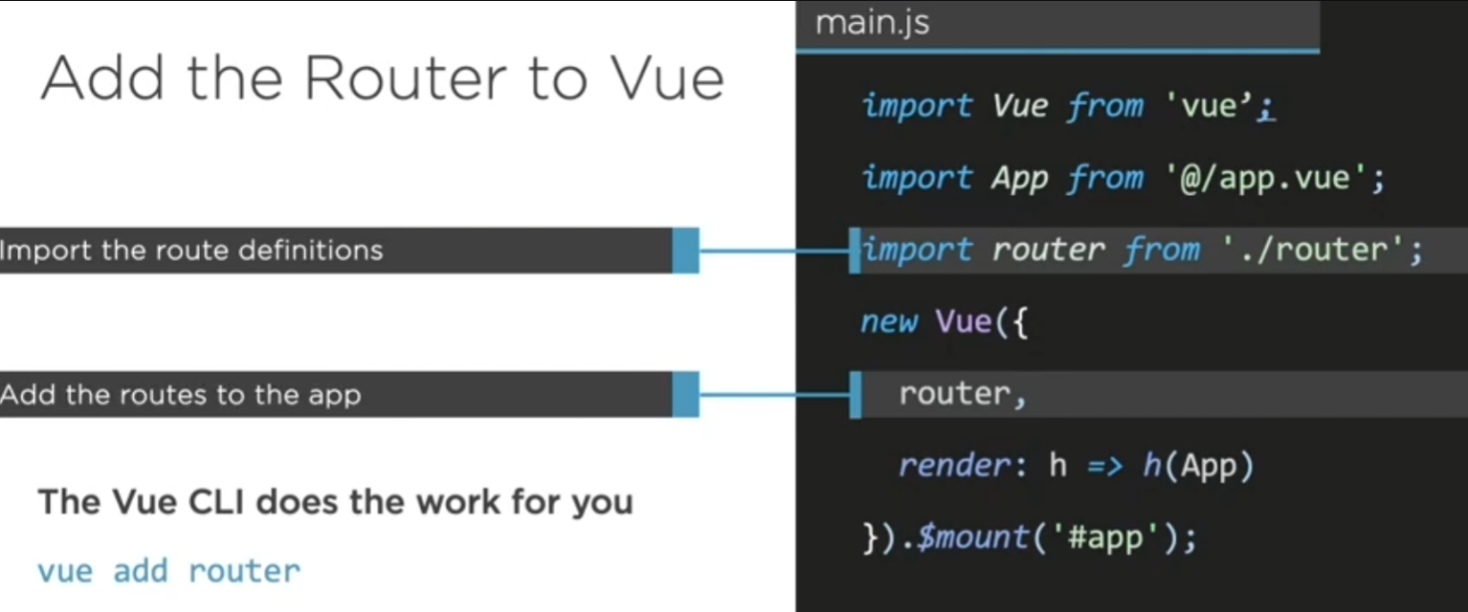



Vue Cli will Create route.js for you

1. Modify router.js file

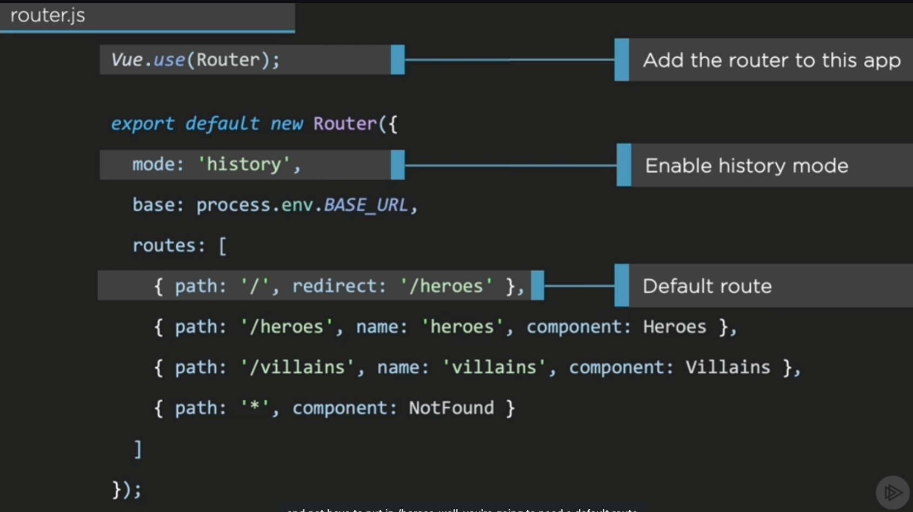

**Mode is set to history by default (another choose is using hash routing)

>> 按上一頁時會記得上一頁在哪

1. Demo

>> beside npm run serve, another command is npm run dev, which runs a fake backend against a json server and vue server together

1. Use vue cli to add router

>> 注意，有些指令不能在power shell執行的，vs code可以開git bash的terminal!



(git 相關其實也在vscode裡面就能完成了)

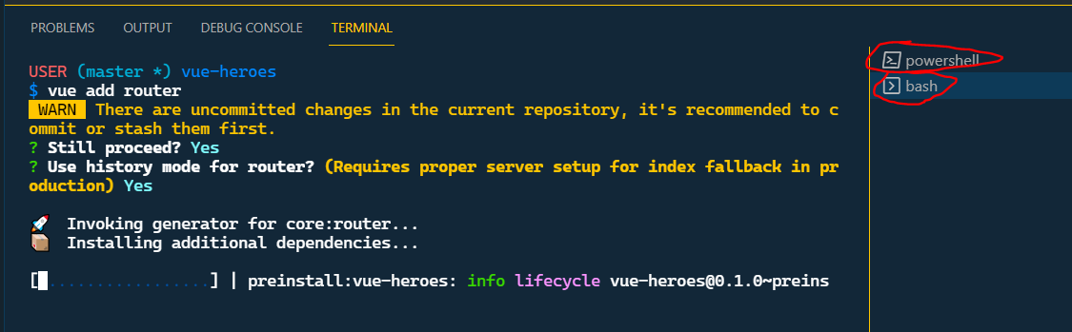



>> can see after vue add router, several files are added and several are modified(add dependency)

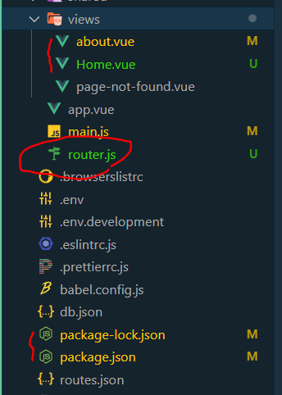

>> then discard the about.vue and Home.vue using git unchange function in vscode

>> about is instruction file

>> and Home.vue is just the demo file (like weather forecast in c# api)

3.Move page file to view folder

>> by convention, view folder put the page file, and component put the stuffs that’s are nested in the page!!

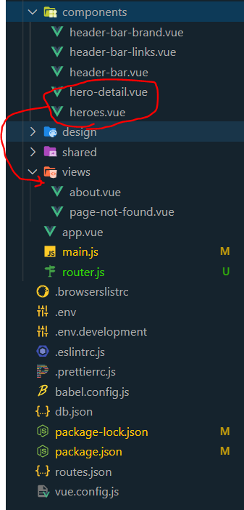

1. modify router.js file

>> first change Home.vue to your page component

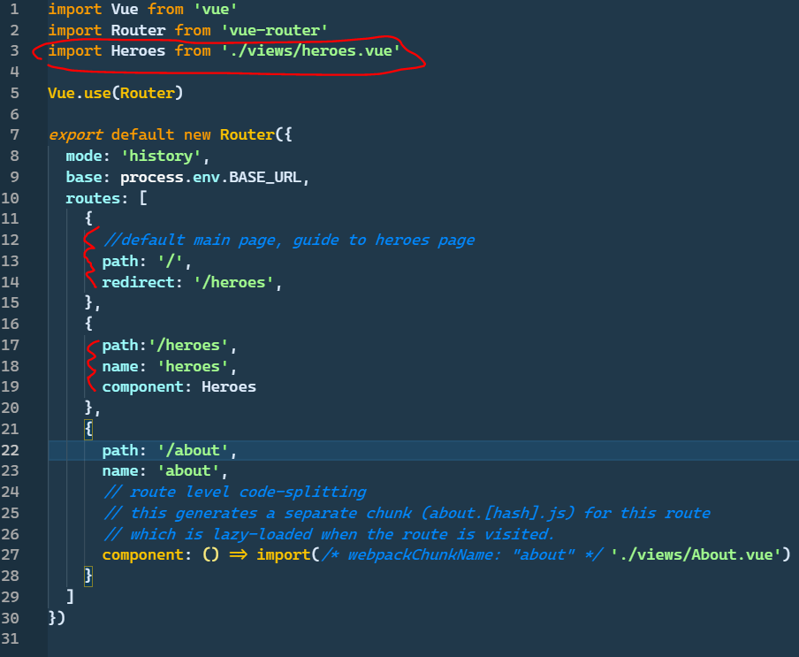

>> first, change import component from home(default) to your component

>>second, set your routes (remember the default page)

1. modify main page >> app.vue

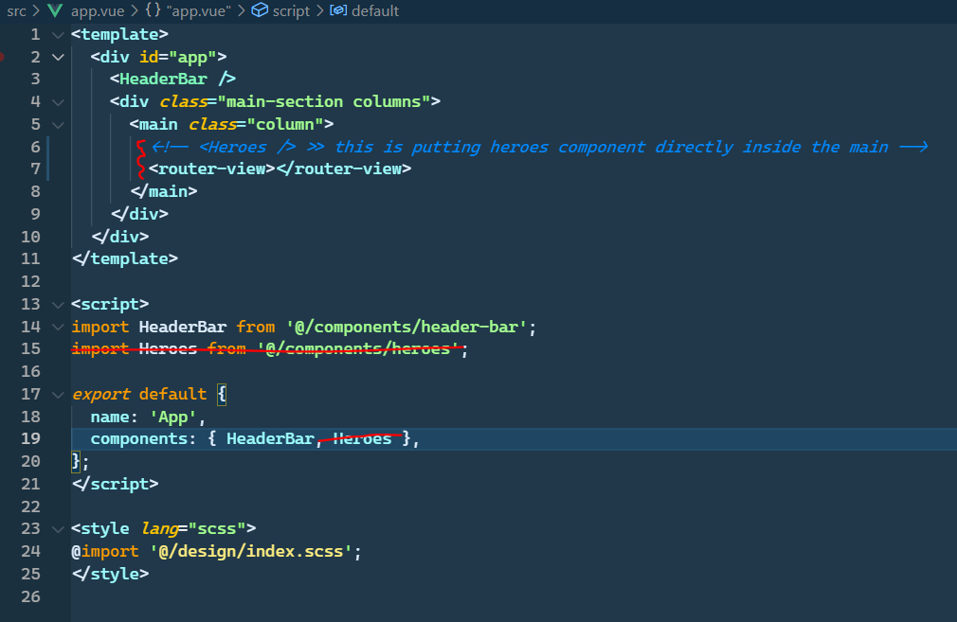

Put the router in, and then delete the import and the component here (don’t take it directly)

>> finish state:

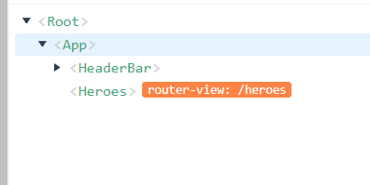



* Adding navigation:

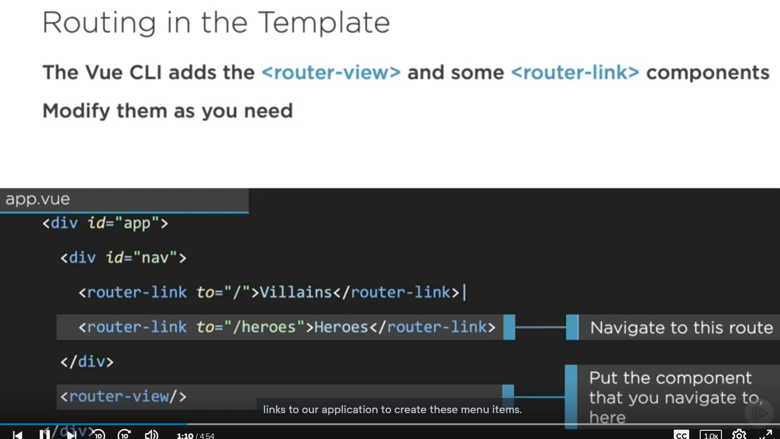



1. Build navbar component and set the route link use “vroute”:

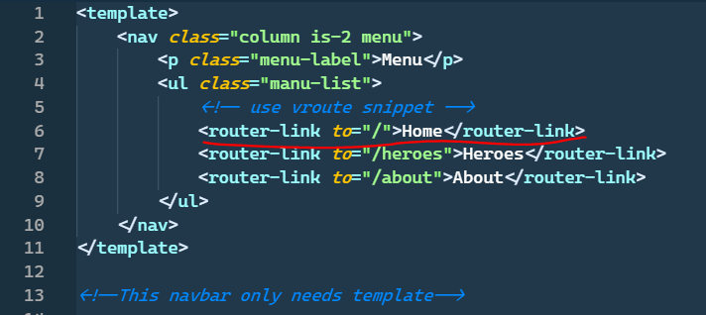

1. Put component into app.vue (main component)

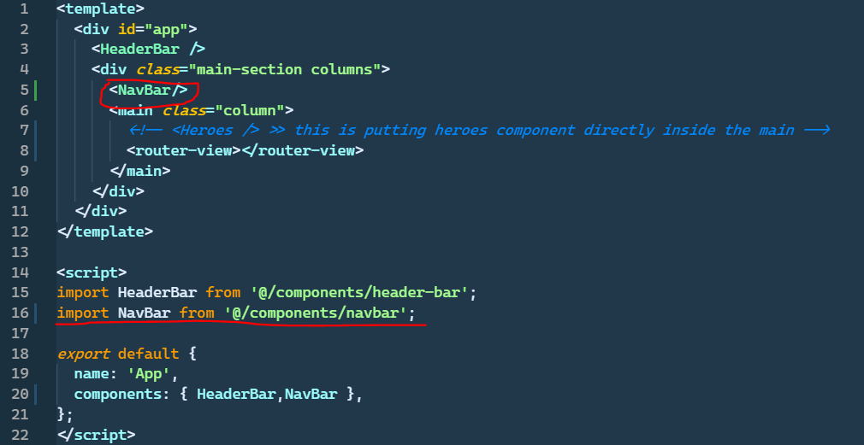

1. 找時間要去研究button style 怎麼建置的 (選取時切換)



* Define and passing routing parameter

將hero detail 部分做修改，從用v-if轉為使用router

1. 一樣先去router.js 把route定義好之後將component輸入route.js

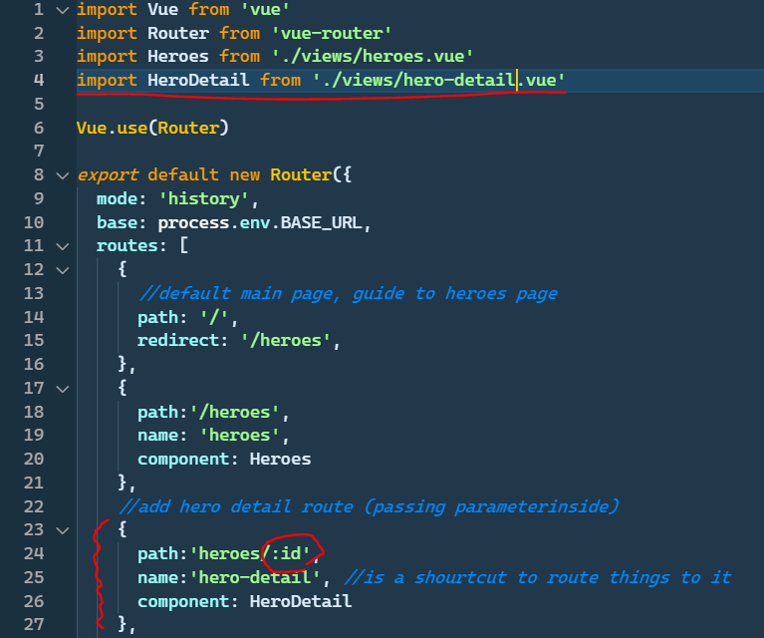

>> way to pass parameter using ‘ : ’

1. Remove v-if and using router

>> remove all things with “selectedHero” cause we pull thing out of the component and put the hero detail into router

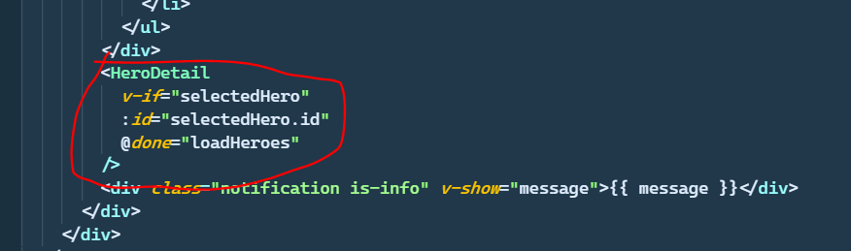

To

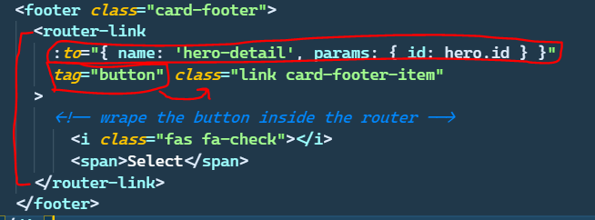

Finally back to router.js and set the ‘props’ to true, to let the ‘id’ be passed back and has a prop in hero-detail

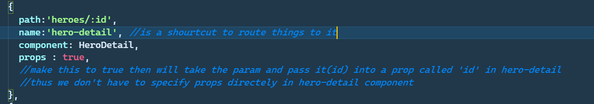



*注意: 將param回傳變props 的default type是 string，須做變化:

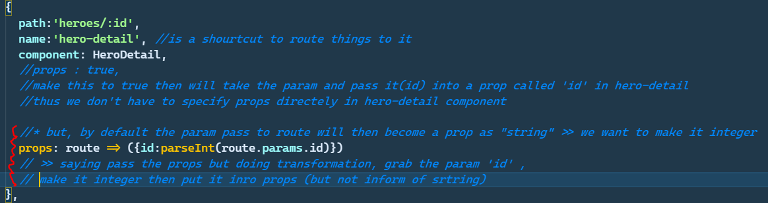

* **Setup lazy loading**

So far we’re using the eager loading (一進入頁面就先load所有component)

>> vue可以做lazy loading，當一個component被叫到時才去load該component

>>更厲害的是可以放一組component(彼此相關，一個被叫到之後另一個通常也會被叫到)

>>當某一component被叫到時，該bundle的component都會load

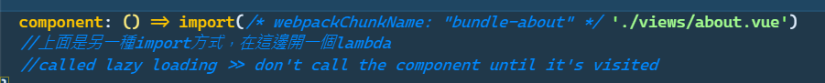



>> lazy loading設定模式

webPackChunkName : 群祖名設定 >> inline comment，讓vue看懂

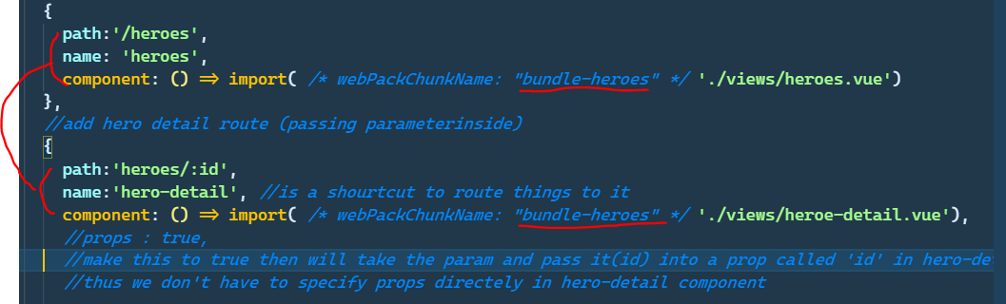

>> lazy loading 的群組設定

* Navigate rout through code (邏輯換頁)

>> use the $router api in methods (upon event)

Ex: working on cancel and save button on hero-detail

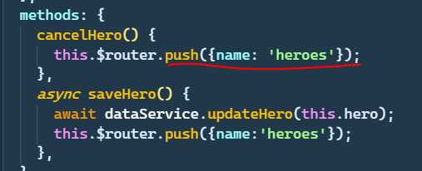



Specify what route you want to go to!

Recap:

